Subject: Practical DevOps
Experiment No.: 1 (Group Activity)
Topic: Version Control System & Source Code Management using Git and GitHub
Department: Department of AI & Data Science
Institute: SCTR’s Pune Institute of Computer Technology

Group Work Division Summary
- Student 1 (Imran Mulani - Roll No: 34148): Local repository initialization (git init), basic tracking (student_details.txt), commit 1 & 2 (4a896d5 & 69e03dc), GitHub remote linking, and initial push.
- Student 2 (Aniket More - Roll No: 34147): Cloning repository (git clone), adding group info (About_Group.txt), commit & pushing to GitHub.
- Student 3 (Onkar Mandlik - Roll No: 34143): Repository documentation (README.md creation using Markdown), commit, pushing updates, and git log / git diff change tracking.

1. Aim
To create a local Git repository, understand fundamental version control operations (staging, committing, tracking history), set up remote tracking on GitHub, and practice collaborative software development in a 3-member team.

2. Objectives
- Understand the working mechanics of Git local repositories and file status tracking.
- Link a local Git repository to a remote repository hosted on GitHub.
- Collaborate within a multi-developer setup using operations like clone, pull, and push.
- Document software projects effectively using Markdown (README.md).
- Analyze commit logs and inspect repository history using version comparison tools (git log, git diff, git show).

3. Software and Tools Used
- Operating System: Ubuntu / Linux
- Version Control System: Git
- Terminal Environment: Linux Terminal / Command Line
- Hosting Platform: GitHub
- Text Editor: VS Code / Terminal Text Editor (nano/vim)

4. Group Members
- Student 1 (Student A - Main / Local Setup): Imran Mulani (Roll No: 34148)
- Student 2 (Student B - Collaborator 1): Aniket More (Roll No: 34147)
- Student 3 (Student C - Collaborator 2): Onkar Mandlik (Roll No: 34143)

5. Theory
A Version Control System (VCS) is a tool that tracks changes to files over time, allowing developers to recall specific versions later. Git is a distributed version control system where every developer has a full copy of the repository history locally.

Key Git Concepts:
- Working Directory: The directory where files are currently created or modified.
- Staging Area (Index): A draft area where changes are collected before being committed.
- Local Repository: Stores committed snapshots of the project history locally (.git directory).
- Remote Repository: Hosted on platforms like GitHub to facilitate team collaboration and synchronization.

6. Step-by-Step Procedure

Activity 1 & 2: Local Setup & Remote Synchronization (Student 1: Imran Mulani)
- Created directory 34148 and initialized Git repository using git init.
- Created student_details.txt with group details.
- Checked repository status using git status.
- Staged and committed file using git add student_details.txt and git commit -m "Initial commit".
- Modified student_details.txt by adding "Practical DevOps Experiment 1" using echo command.
- Staged and committed updated file with git commit -m "Added Practical DevOps Experiment 1".
- Verified history logs using git log and git log --oneline.
- Created remote repository on GitHub named DevOps-Practical-Group01.
- Linked remote URL using git remote add origin <Repository_URL> and pushed to main branch using git push -u origin main.

Activity 3: Collaborative Development (Student 2: Aniket More)
- Student 2 (Aniket More) cloned the remote repository:
git clone <Repository_URL>
- Created a new file About_Group.txt containing group member details.
- Staged, committed, and pushed changes:
git add About_Group.txt
git commit -m "Added group information"
git push origin main
- Student 1 (Imran Mulani) pulled the updated changes locally using git pull origin main.

Activity 4: Repository Documentation (Student 3: Onkar Mandlik)
- Student 3 (Onkar Mandlik) created README.md with Markdown formatting (headings, lists, commands used, and learning outcomes).
- Staged, committed, and pushed the README file:
git add README.md
git commit -m "Updated README"
git push origin main
- Verified output rendering directly on GitHub interface.

Activity 5: Git History and Change Tracking (All Members / Student 3 Lead)
- Executed git log to verify complete team commit history.
- Used git diff to view line-level changes made between versions.
- Used git show <commit-id> to inspect individual commit snapshots.

7. Summary of Git Commands Used
Command | Description | Executed By
git init | Initializes a new local Git repository | Imran Mulani
git status | Displays state of working directory and staging area | Imran Mulani
git add <file> | Adds modified file(s) to staging area | All Students
git commit -m "msg" | Saves staged changes as a snapshot | All Students
git log / git log --oneline | Displays chronological commit history | All Students
git remote add origin <url> | Connects local repository to GitHub remote | Imran Mulani
git remote -v | Verifies connected remote URLs | Imran Mulani
git push -u origin main | Uploads local commits to remote GitHub repository | All Students
git clone <url> | Downloads remote repository copy locally | Aniket More
git pull | Fetches and merges latest remote updates | Imran / Onkar
git diff | Shows differences between working files/commits | Onkar Mandlik
git show <commit-id> | Shows details and diff for a specific commit | Onkar Mandlik

8. Command Outputs & Commit History Table

Group Commit History Table
Commit No. | Commit ID (Hash) | Commit Message | Author / Student | Key Changes Made
1 | 4a896d5 | Initial commit | Imran Mulani (34148) | Initialized repository & created student_details.txt.
2 | 69e03dc | Added Practical DevOps Experiment 1 | Imran Mulani (34148) | Appended experiment header to student_details.txt.
3 | b72e19f | Added group information | Aniket More (34147) | Cloned repo & added About_Group.txt.
4 | f10a82c | Updated README | Onkar Mandlik (34143) | Added structured README.md documentation.

9. Screenshots (Activity & Student Wise)

Activity 1 & 2: Local Setup & Commits (Student 1: Imran Mulani)
Screenshot 1.1: Git Repository Initialization (git init)

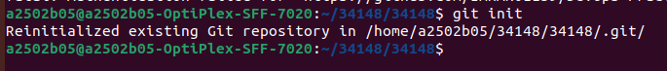

Screenshot 1.2: Repository Status Check (git status)
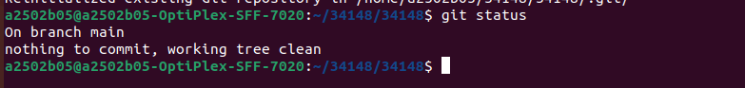
Screenshot 1.3: First Commit & Oneline Log (git commit & git log --oneline)
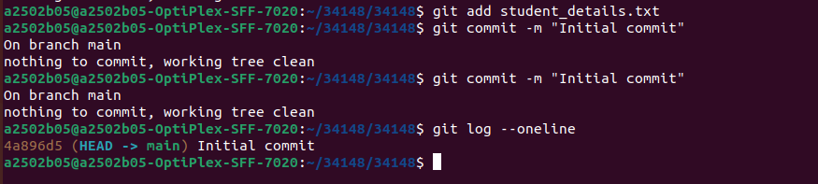
Screenshot 1.4: File Modification & Second Commit (echo & git commit)
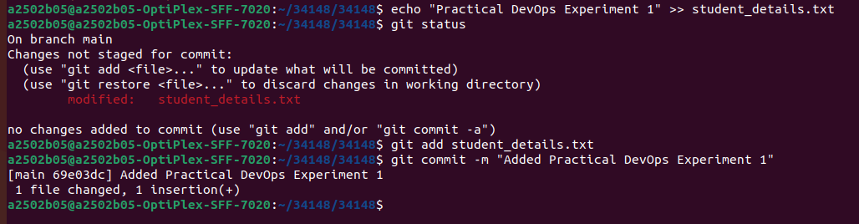
Screenshot 1.5: Detailed Commit Log (git log)
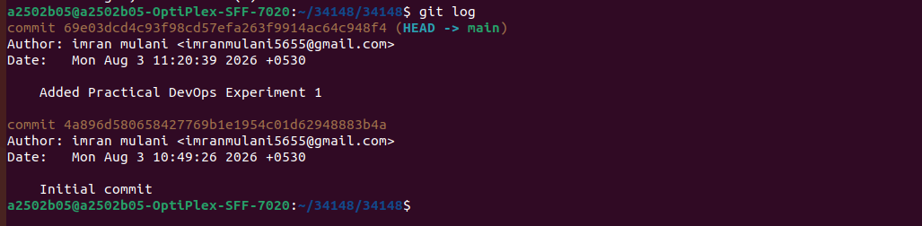
Screenshot 2.1: Remote Origin Link & Push to GitHub (git remote add & git push)
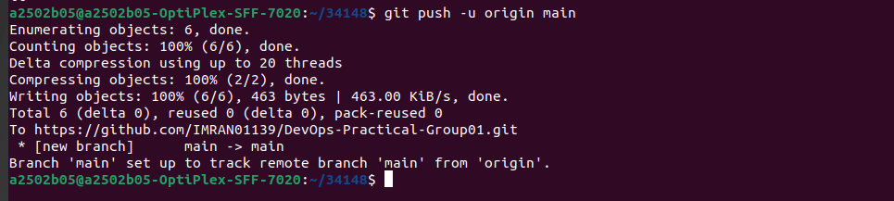

Activity 3: Collaborative Development (Student 2: Aniket More)
Screenshot 3.1: Repository Cloning (git clone)
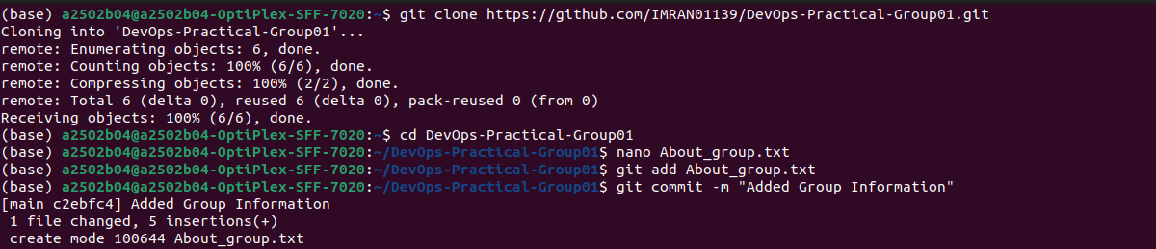
Screenshot 3.2: Creating File (About_Group.txt) & Pushing Changes
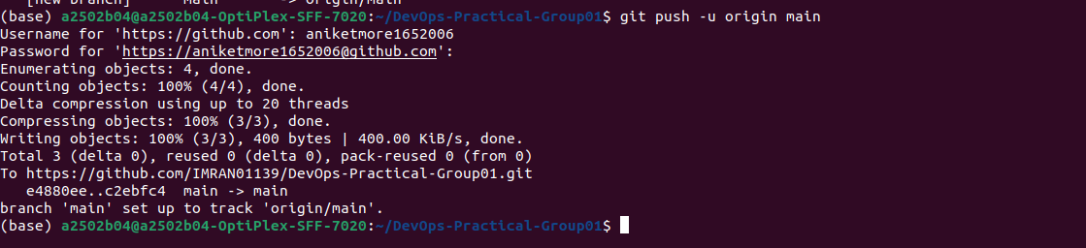
Screenshot 3.3: Pulling Remote Updates (git pull)
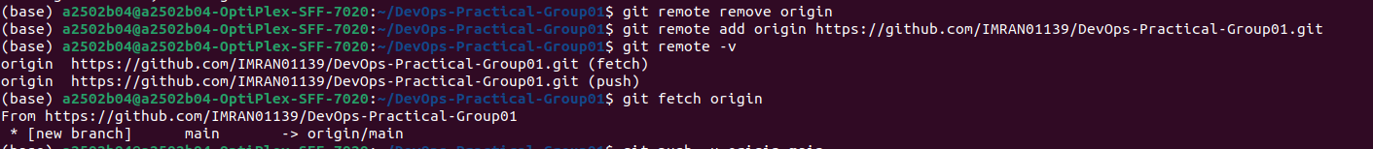

Activity 4: Project Documentation (Student 3: Onkar Mandlik)
Screenshot 4.1: Creating and Editing Markdown File (README.md)
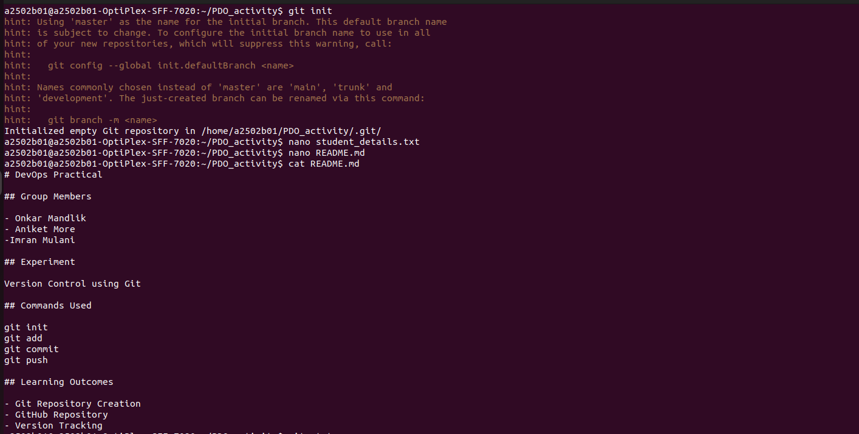
Screenshot 4.2: README Displayed on GitHub Repository Page
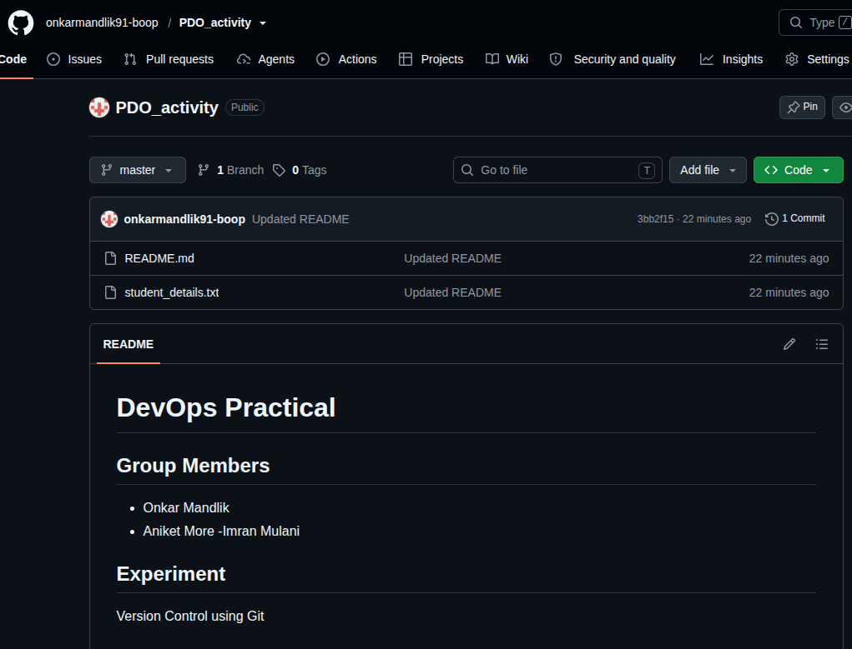

Activity 5: Git History & Difference Tracking (Student 3: Onkar Mandlik)
Screenshot 5.1: Combined Team Log (git log)
┌──────────────────────────────────────────────────────────┐
│ │
│ [ PASTE COMBINED GIT LOG SCREENSHOT HERE ] │
│ │
└──────────────────────────────────────────────────────────┘
Screenshot 5.2: Inspecting File Differences (git diff)
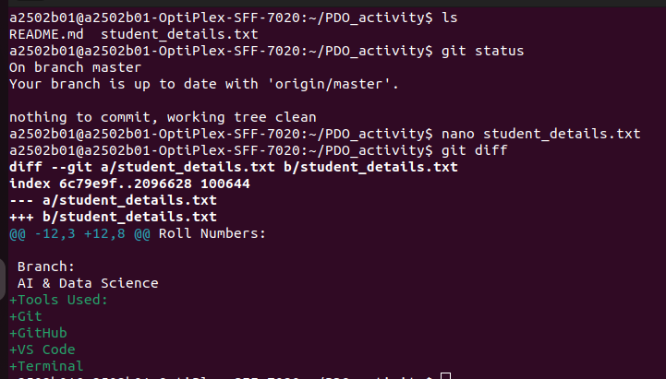
Screenshot 5.3: Commit Details Output (git show)
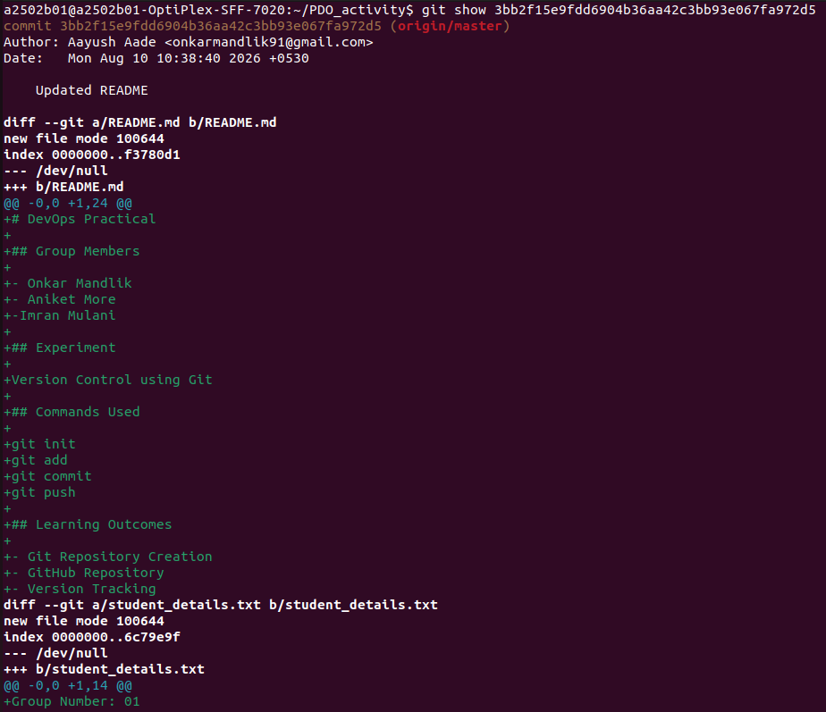

10. Observations
- git init creates the hidden .git folder required for tracking version histories locally.
- Unstaged changes detected by git status need to be explicitly staged using git add before committing.
- Every commit produces a unique SHA-1 hash (e.g., 4a896d5, 69e03dc) ensuring version accountability.
- Performing git pull prior to pushing updates prevents merge conflicts when multiple members work on the same repository.

11. Learning Outcomes
- Successfully initialized, staged, and committed local file changes using Git.
- Linked local projects to remote GitHub repositories for cloud synchronization.
- Executed collaborative developer workflows (clone, push, and pull) across a 3-member team.
- Formatted project documentation cleanly using Markdown in README.md.
- Evaluated software evolution using inspection tools like git log, git diff, and git show.

12. Conclusion
Through this group experiment, our 3-student team (Imran Mulani, Aniket More, and Onkar Mandlik) successfully set up a local Git repository, synchronized it with GitHub, and executed a collaborative Git workflow. We learned how to maintain version control, document project details using Markdown, and manage multi-developer contributions cleanly.

